Feature Article
Developing Intelligent Warehousing Reducing Logistics Costs and Improving Efficiency
- Strong demand promotes the rapid development of intelligent logistics, with the market size reaching 338 billion yuan in 2018
- Intelligent warehousing is the most effective tool for cost reduction and efficiency increase along the logistics chain
- High performance logistics equipment: empowering intelligent warehousing development

In recent years, China’s express delivery business volume has achieved strong growth, leading the world for five years in a row. The country’s express delivery volume reached 50.71 billion pieces in 2018. On the Double Eleven Day (Singles’ Day) this year, T-Mall’s logistics order volume reached 1.292 billion, while JD’s logistics service achieved 24 hour delivery in 90% of districts and counties nationwide, setting new records in volume and efficiency for e-commerce logistics.
While the “Double Eleven” and “Double Twelve” are celebrated by consumers, they are a race against time for logistics companies. According to data from eMarketer and Project44, two global market research institutions, in the field of e-commerce, the primary factor affecting consumers' shopping experience is related to logistics. What is behind the increasingly “demanding" requirements from the consumer market for logistics speed and services is the transformation of China's logistics industry from reliance on manpower and extensive operation to digitalization and intelligence.
Strong demand promotes the rapid development of intelligent logistics, with the market size reaching 338 billion yuan in 2018
Intelligent logistics realizes the optimized allocation of resources and reduces the operation and management costs of the industry chain. In recent years, China has issued multiple support policies in an effort to continue to promote the intelligent development of the logistics industry. However, a multitude of challenges are still in the way of achieving intelligent logistics. Logistics companies are exploring new business and seeking service innovation to drive future profit growth; e-commerce businesses, due to their unique logistics features, are building their own smart warehouses one after another, to ensure logistics efficiency and labor cost control during large demand fluctuations; the manufacturing sector is constantly optimizing the logistics chain and investing heavily in logistics equipment to achieve reasonable resource allocation.
Intelligent warehousing is the most effective tool for cost reduction and efficiency increase along the logistics chain
Warehousing, transportation and delivery are the three basic elements of the logistics chain. Among them, warehousing takes up most of the merchandise owner company’s capital. In addition, compared with transportation and final delivery, warehousing already has more advanced and mature technical support because it has relatively more simple and controllable application environment. With its high fund occupation and relatively mature smart technologies, the cost reduction and efficiency improvement achieved through intelligent equipment is considered to have higher return on investment than the other elements.
In management and scheduling for intelligent warehousing, smart technologies such as automated equipment, drones, and intelligent identification can control, optimize inventory, as well as improve the response time for the logistics chain. Therefore, developing and upgrading intelligent warehousing has become the “shortcut” to achieving lower costs and higher efficiency. According to the estimate by Gaogong Industry Institute (GGII), the size of the future intelligent warehousing market will reach 197.5 billion yuan by 2023.
Nowadays, automation and unmanned operation are the future for intelligent warehousing. In intelligent warehousing, applying automation technology can achieve a higher operation efficiency and lower rate of error as compared to manual work; unmanned technologies improves accessibility as it connects various working areas in the warehouse, especially those that are not suitable for manual work. Furthermore, unmanned technologies can also avoid excess labor costs caused by unstable order flow. With daily processing capacity of 1.81 million packages, the efficiency of Suning’s Cloud Warehouse is more than 10 times that of manual picking; JD Logistics’ unmanned warehouses have an unboxing and picking efficiency 8 times higher than traditional operation, with an order picking accuracy of up to 99.99%. Automation and unmanned operation not only achieve astonishing efficiency growth, but also greatly improve the accuracy of order picking.
High performance logistics equipment: empowering intelligent warehousing development
In warehousing, Continental’s belts are mainly used to transmit power to the logistics equipment, serve as conveyor loading or provide conveying positioning. With low tension, low noise, precise positioning and maintenance-free features, Continental’s belt products are the preferred choice for logistics equipment suppliers.
In storage systems, the lift is used for vertical transportation of goods, while the key to ensuring lift transportation efficiency is the stability at high speed. Due to their small load and high durability, Continental’s belts are ideal for lifts. In addition, the cogged design of Synchrodrive products enables precise positioning for intelligent logistics equipment. AGV storage robots have many advantages in conveying systems. They prevent product damage caused by incorrect manual operation and negligence, reduce labor costs by transporting between any location, and has a smaller footprint than traditional forklifts, etc. AGV’s advantage has to be further leveraged to achieve higher transportation efficiency. Continental's Synchrobelt timing belts provide great power in a small space that ensures a wide range of operational needs for AGV trolleys. With high durability and long service life, Continental’s belts can considerably reduce maintenance cost for logistics equipment, thus further lowering warehousing costs.
Updating hardware equipment is the basis for achieving intelligent logistics. Unmanned warehousing operation is based on IoT and robotics technologies. Continental continues to provide technical support in the field of intelligent warehousing, with ADAS Radar Sensors, Mobile Fluid Systems and Internet of Vehicles systems being widely used in various logistics stages.
Future intelligent logistics requires high-end intelligent equipment as the basis, next-generation IT approaches to accelerate the expansion of application scenarios, and the development of more mature commercial operation modes. With a booming intelligent logistics market, Continental will also continue to explore new applications in logistics to provide high-quality and complete solutions for logistics equipment suppliers.

Continental develops pioneering technologies and services for sustainable and connected mobility of people and their goods. Founded in 1871, the technology company Continental offers safe, efficient, intelligent and affordable solutions for vehicles, machines, traffic and transport. In 2018, Continental generated sales of €44.4 billion and currently employs some 240,000 people in 60 countries and regions.
ContiTech is one of the world’s leading industrial specialists. The Continental division offers its customers connected, environment-friendly, safe and convenient industry and service solutions using a range of materials for off-highway applications, on rails and roads, in the air, under and above the ground, in industrial environments, for the food and the furniture industry. The division employs approximately 47,000 people in 42 countries and regions around the world, generating sales of €6.3 billion (2018). The division is active in Asia, Europe, North America and South America as a global industry partner.
Press Contact
Li Che  Head of Corporate Communications China  ContiTech Division  Tel: +86 21 6080 2500  Fax: +86 21 6080 2598  E-mail: Li.che@continental.com  Website: www.continental-industry.com | Minami Zheng  Corporate Communications China  ContiTech Division  Tel: +86 21 6080 2541  Fax: +86 21 6080 2598  E-mail: Minami.zheng@continental.com  Website: www.continental-industry.com

This press release is available in the following languages: English and Chinese

Links
News portal www.continental-press.cn
Media center continental.com/media-center
ContiTech China Official WeChat

Caption:
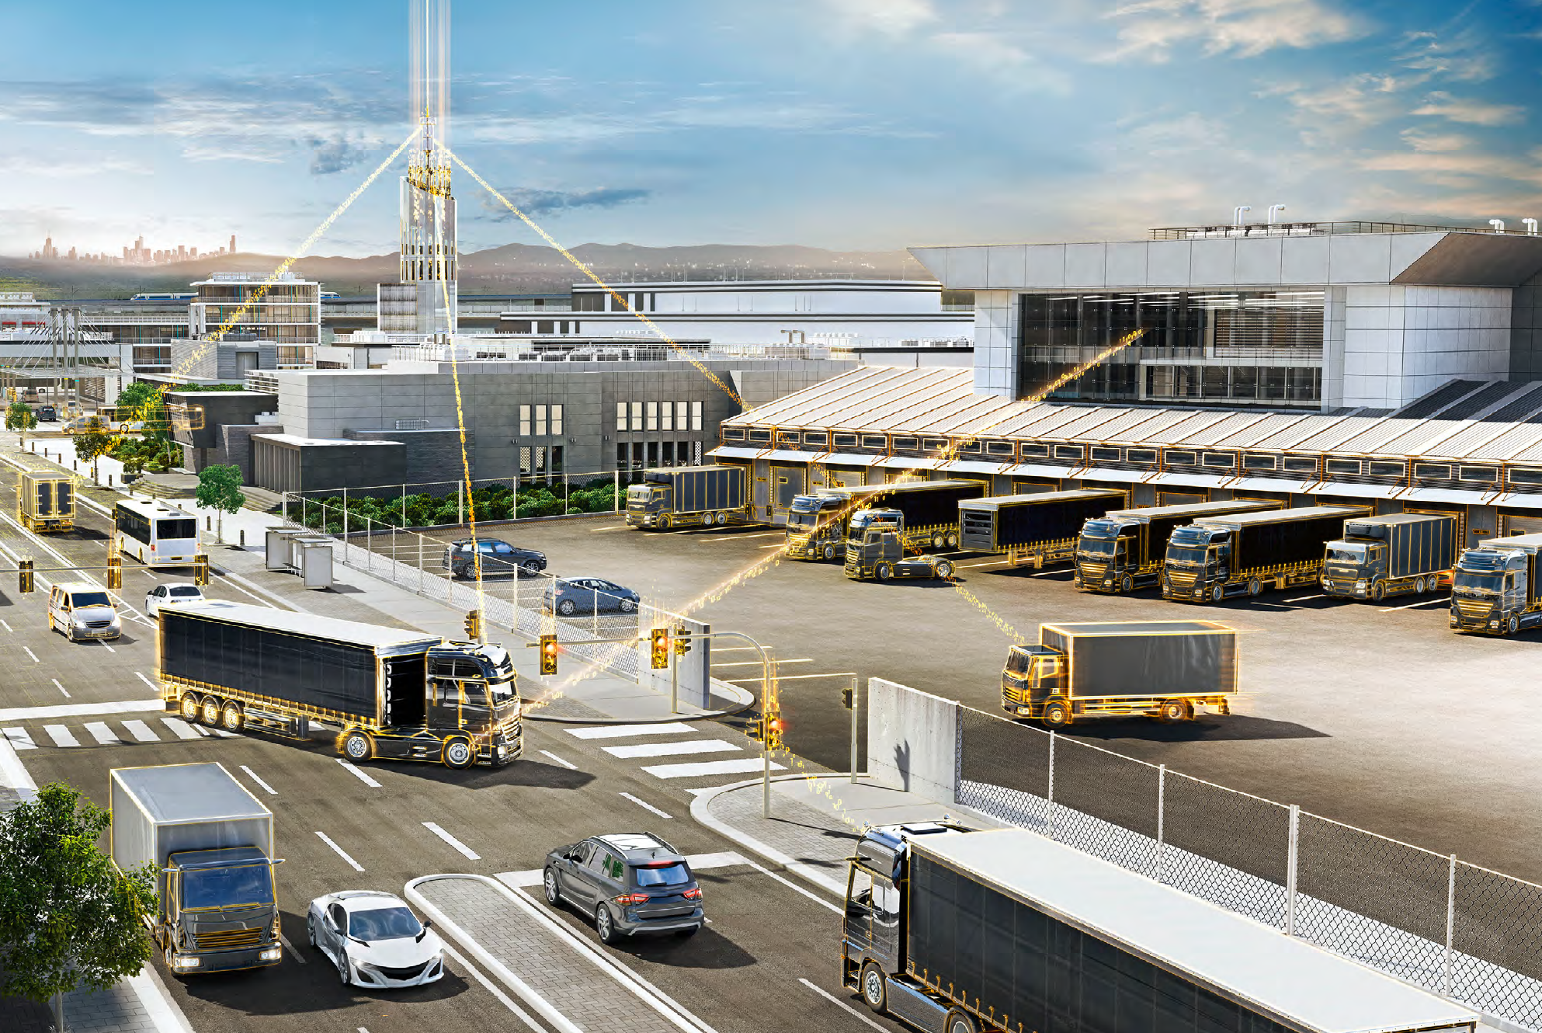  Continental_PP_ Intelligent Logistics.JPG | Future intelligent logistics.  Photo: Continental

China News. China’s Express Service Leads the World for Five Years in a Row http://www.chinanews.com/cj/2019/11-08/9002534.shtml
The Economic Observer. 2019 T-Mall Double Eleven GMV Hits 268.4 Billion Yuan. Number of Total Logistics Orders Surpasses 1.292 Billionhttp://www.eeo.com.cn/2019/1112/369243.shtml
Tencent Tech. JD Logistics Achieves 24 Hour Delivery for 90% of Districts and Counties Bringing China’s Logistics to the 24 Hour Era https://tech.qq.com/a/20191111/008898.htm
Meigushe (US Stock Research Club). How Do Traditional Retailers Find a Way Out While Amazon & Walmart Invest More in Logistics? https://www.meigushe.com/company/5433.html
China Business Network. Promising Prospect for Intelligent Warehousing: Lithium Battery Leader Wants a Piece of the Ten-Billion-Strong Market https://www.yicai.com/vip/news/100209779.html

